Practical No. 4
Aim: Create and simulate a simple adhoc network

1. Download Omnet from
https://omnetpp.org/download-items/omnetpp/omnetpp-422.html 4.2.2
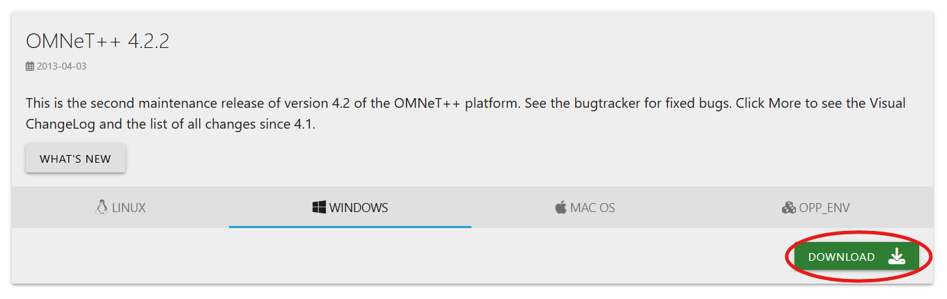
2. Now extract the downloaded file
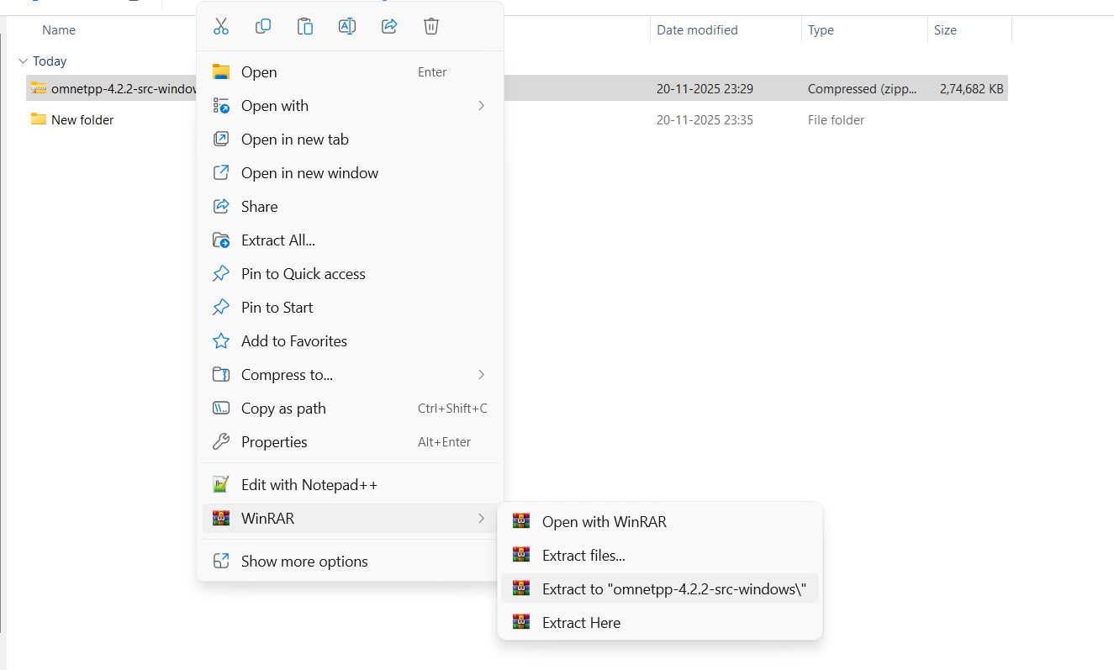

3. After the extraction is completed open the extracted folder and run the mingwenv.cmd
omnetpp-4.2.2-src-windows > omnetpp-4.2.2 > mingwenv.cmd
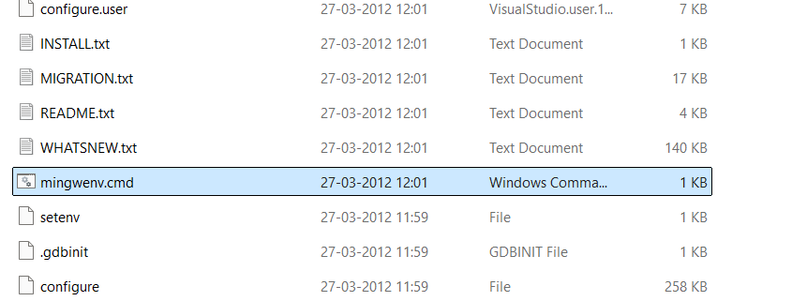
4. After running the file command prompt will appear, type these two commands into it.
1. ./configure 2. make
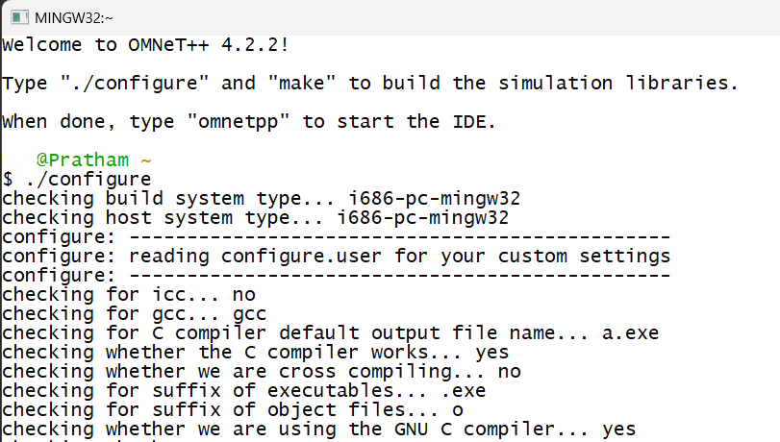
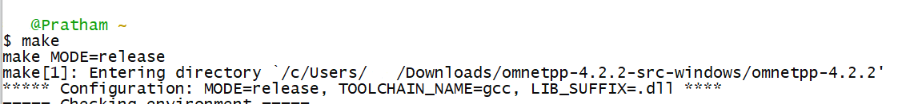

4. Let those commands run completely and then check if omnet++ is installed by entering command omnetpp
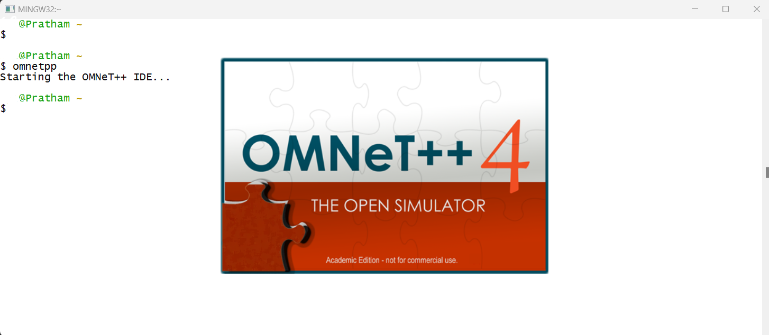

5. After installing Omnet++, we need to install inet framework version 2.1.0 which is
specially designed for wireless simulation. You can download inet framework from
below link. https://inet.omnetpp.org/Download.html
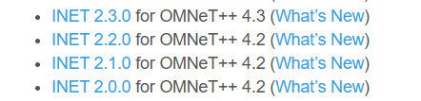
6. After downloading the Inet 2.1.0 extract it to inet-2.1.0-src
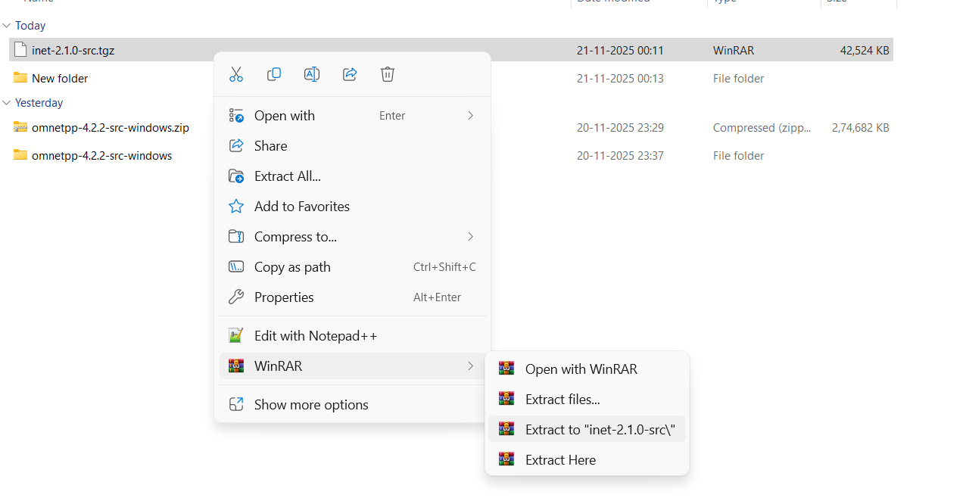

7. Open Omnet++ idle, Click on File > Import. A window will appear in that click on General > Existing Projects in Workspace.
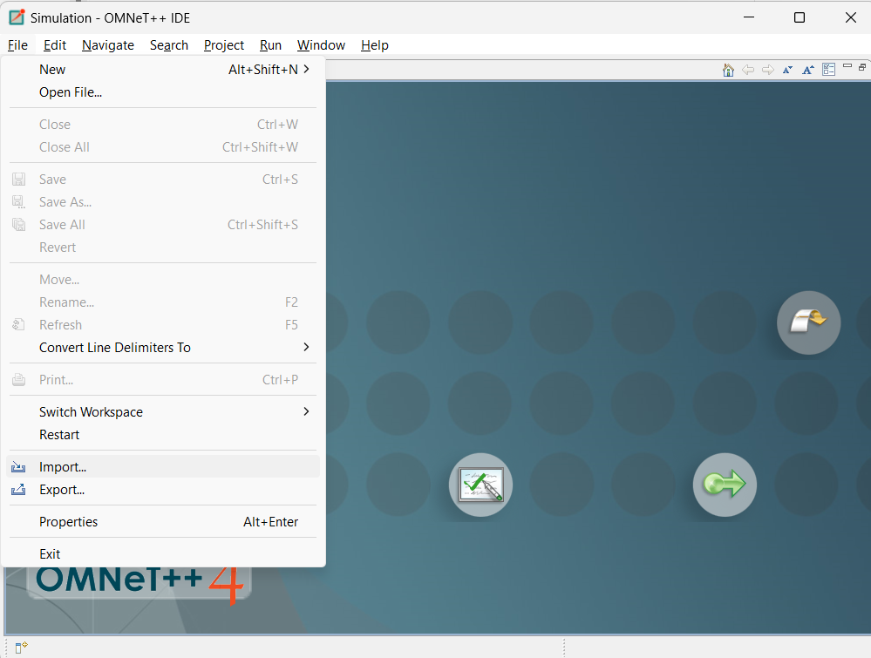

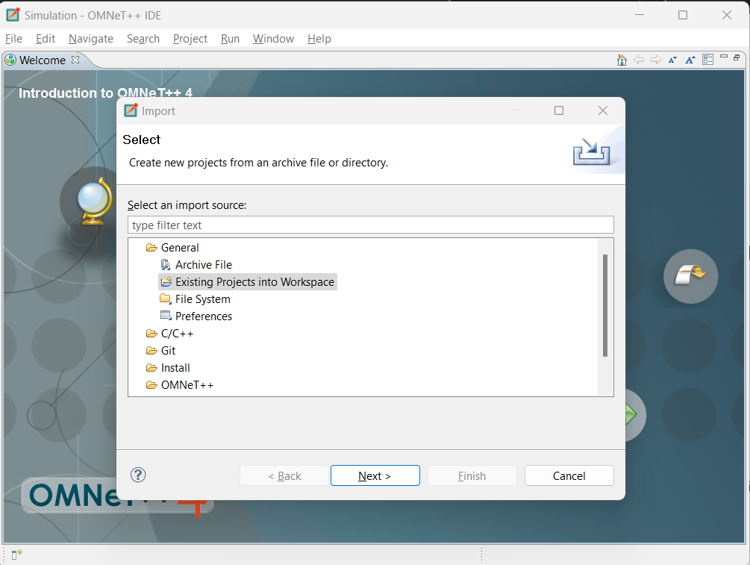
8. Click next and in the root directory browse for the inet-2.1.0-src folder which was created.

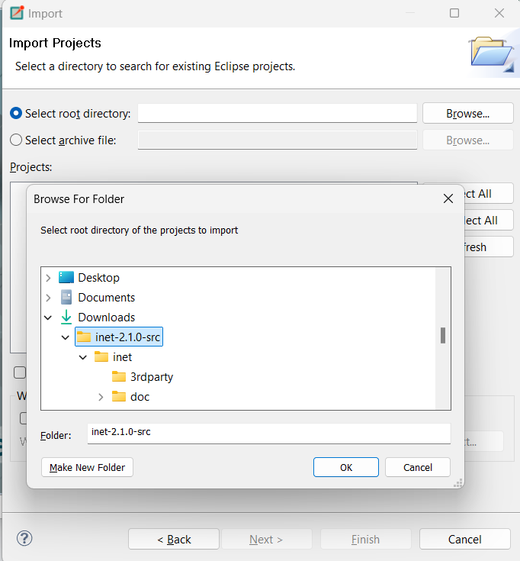

9. Click the checkbox to copy the projects into the workspace and then Finish.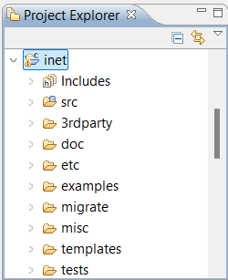
10. Expand the inet folder > examples > adhoc. Right click on adhoc > New > Folder as SimpleAdhoc
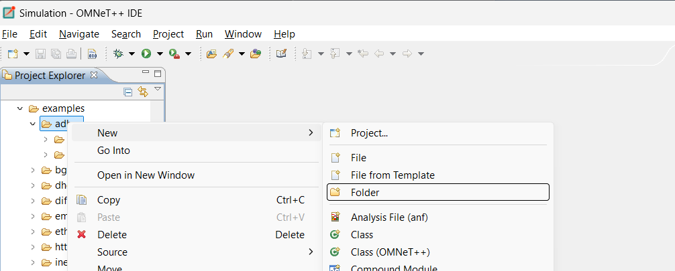

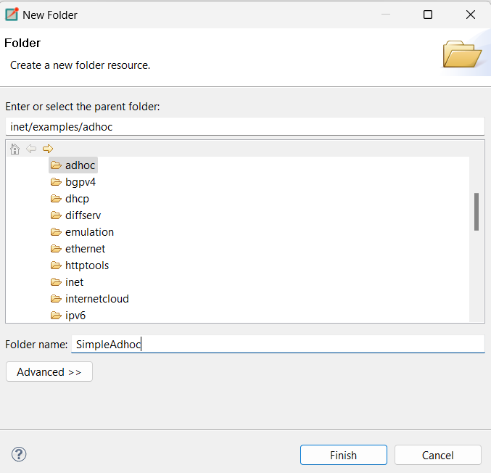
11. Right click on SimpleAdhoc > New > Network Description File (NED). Name the file as Net1.ned
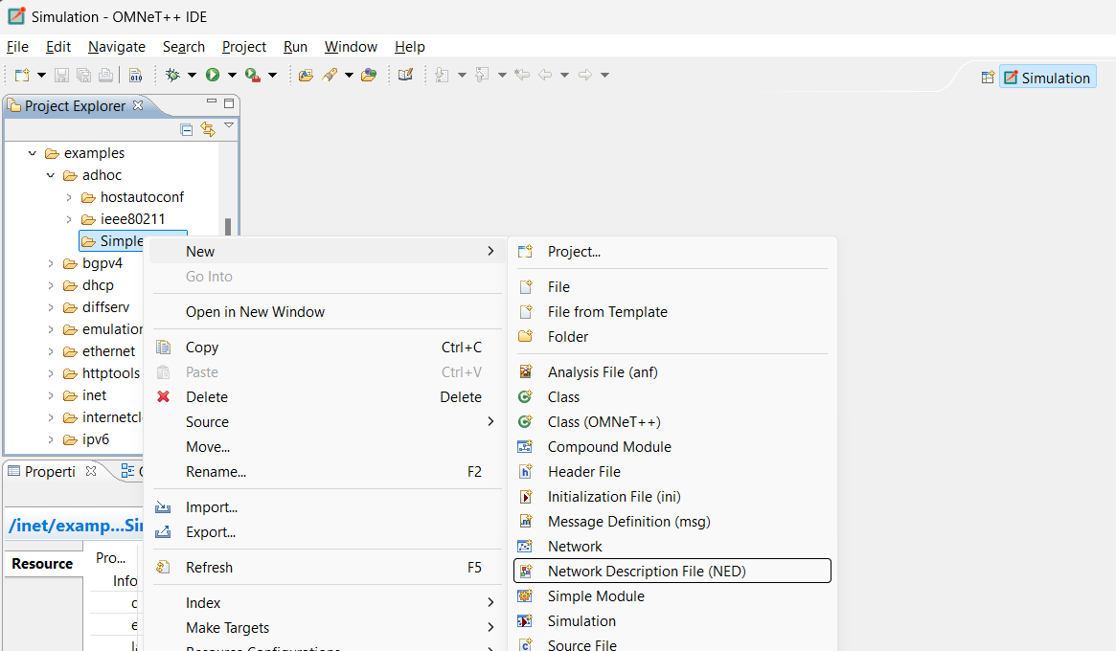
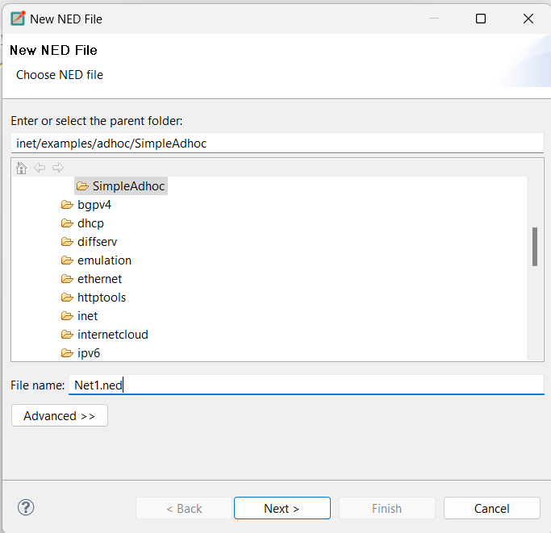

12. Select New Managed Mobility Wireless Network Wizard and Click Next.
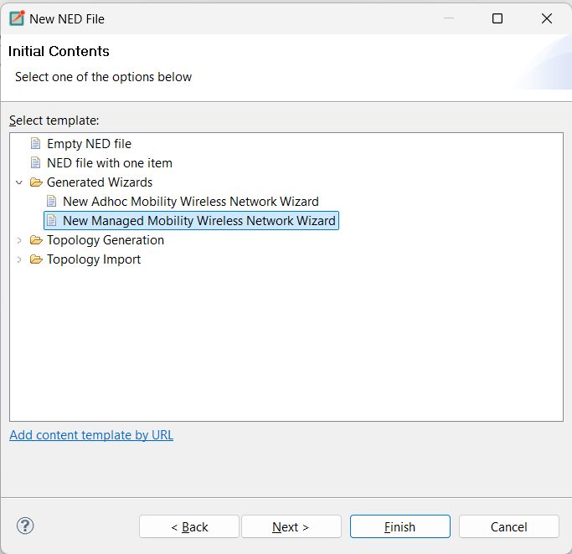
13. Configure as follow
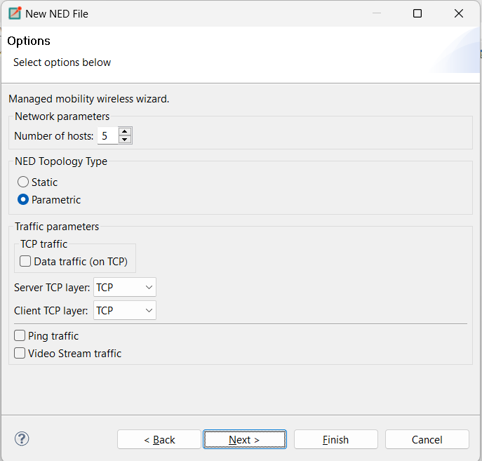
14. Click on Finish
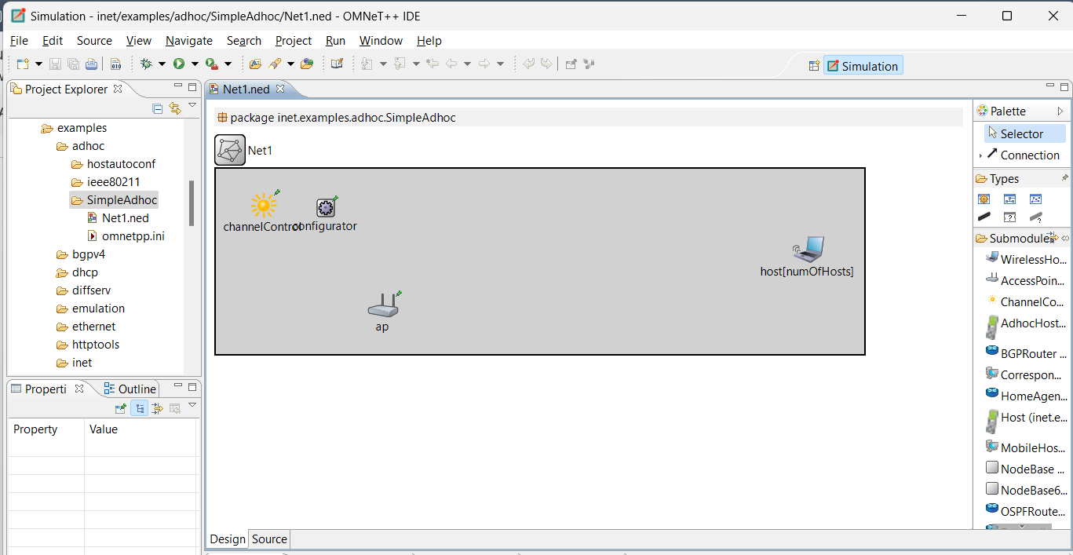

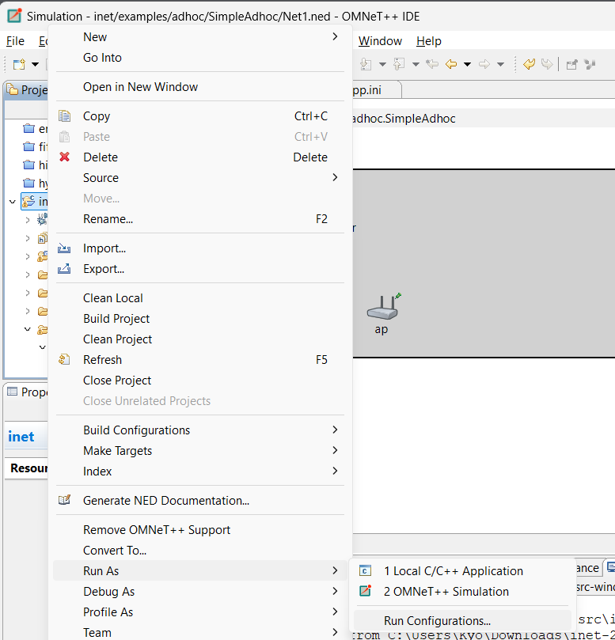
15. To configure, Right click on inet folder > Run as > Run Configurations.

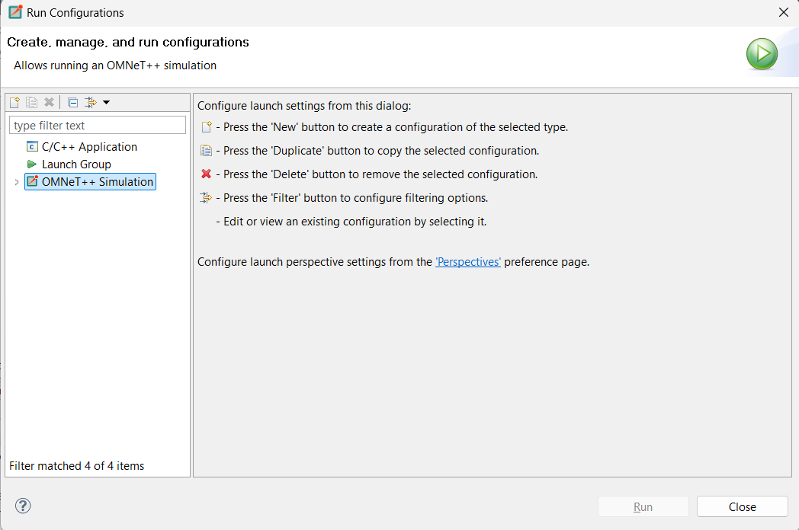
16. Click on OMNeT++ Simulation. Browse the directory where the project is > Apply > Run.
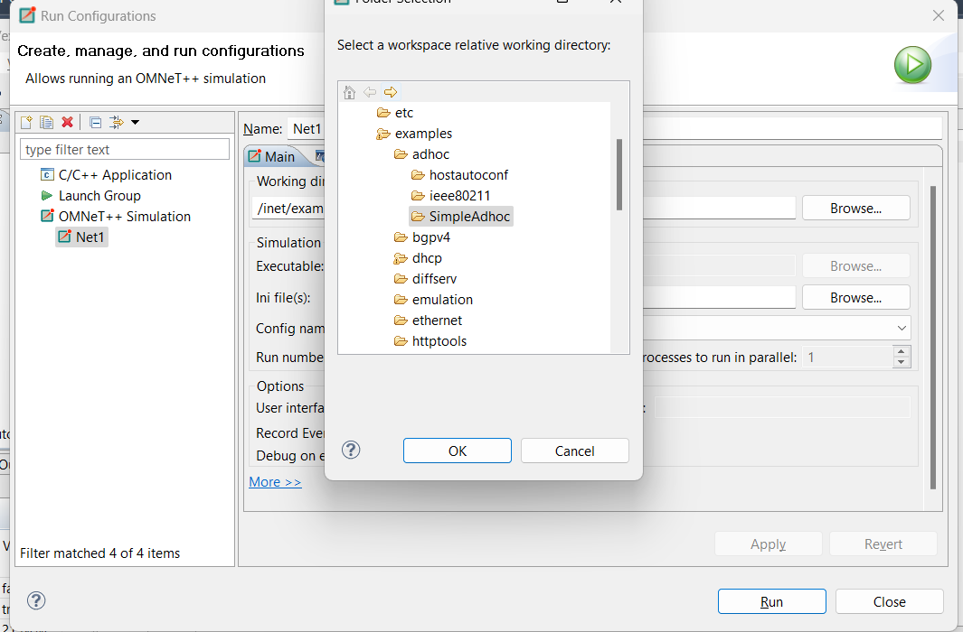
17. Now try to execute by right click on ned file Run as-1-Omnet++ simulation.
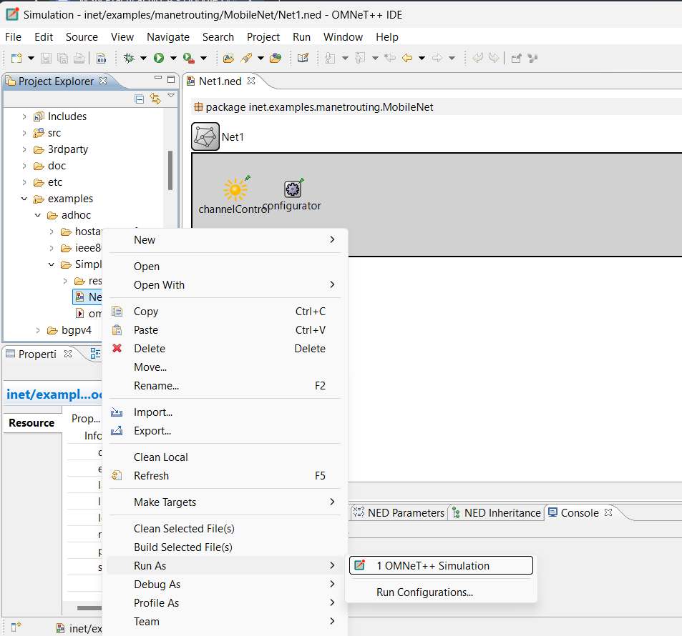
Output: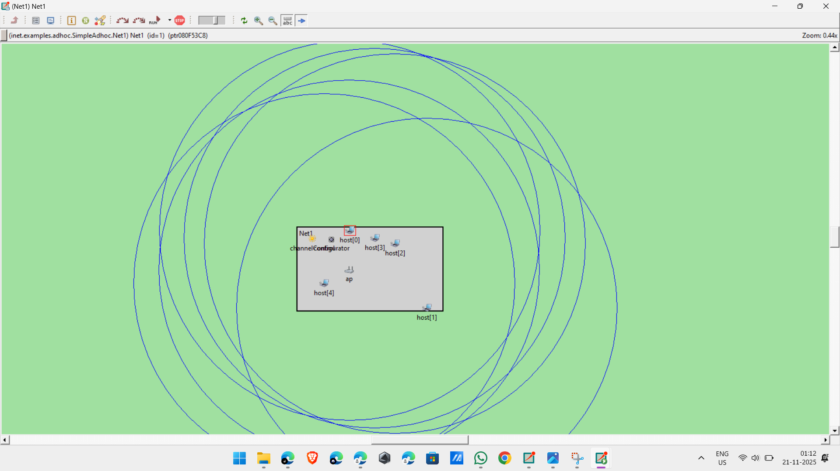

Following will be the code available in
Net1.ned
package inet.examples.adhoc.SimpleAdhoc;

// numOfHosts: 5

import inet.networklayer.autorouting.ipv4.IPv4NetworkConfigurator; import inet.nodes.inet.WirelessHost; import inet.nodes.wireless.AccessPoint; import inet.world.radio.ChannelControl;

network Net
{ parameters: int numOfHosts;

submodules: host[numOfHosts]: WirelessHost
{
@display("r=,,#707070");
}

ap: AccessPoint
{
@display("p=213,174;r=,,#707070");
}

channelControl: ChannelControl
{
numChannels = 2; @display("p=61,46");
}

configurator: IPv4NetworkConfigurator
{
@display("p=140,50");
}
}

omnetpp.ini
[General] network = Net1

*.numOfHosts = 5

#debug-on-errors = true tkenv-plugin-path = ../../../etc/plugins

**.constraintAreaMinX = 0m
**.constraintAreaMinY = 0m
**.constraintAreaMinZ = 0m
**.constraintAreaMaxX = 600m
**.constraintAreaMaxY = 400m
**.constraintAreaMaxZ = 0m
**.debug = true
**.coreDebug = false
**.host*.**.channelNumber = 0

# channel physical parameters
*.channelControl.carrierFrequency = 2.4GHz
*.channelControl.pMax = 2.0mW
*.channelControl.sat = -110dBm
*.channelControl.alpha = 2

# mobility
**.host*.mobilityType = "MassMobility"
**.host*.mobility.initFromDisplayString = false
**.host*.mobility.changeInterval = truncnormal(2s, 0.5s)
**.host*.mobility.changeAngleBy = normal(0deg, 30deg)
**.host*.mobility.speed = truncnormal(20mps, 8mps)
**.host*.mobility.updateInterval = 100ms

# ping app (host[0] pinged by others)
*.host[0].numPingApps = 0
*.host[*].numPingApps = 2
*.host[*].pingApp[*].destAddr = "host[0]"
**.pingApp[0].startTime = uniform(1s,5s)
**.pingApp[1].startTime = 5s+uniform(1s,5s)
**.pingApp[*].printPing = true

# nic settings
**.wlan[*].bitrate = 2Mbps
**.wlan[*].mgmt.frameCapacity = 10 **.wlan[*].mac.address = "auto"
**.wlan[*].mac.maxQueueSize = 14
**.wlan[*].mac.rtsThresholdBytes = 3000B
**.wlan[*].mac.retryLimit = 7
**.wlan[*].mac.cwMinData = 7
**.wlan[*].radio.transmitterPower = 2mW
**.wlan[*].radio.thermalNoise = -110dBm
**.wlan[*].radio.sensitivity = -85dBm
**.wlan[*].radio.pathLossAlpha = 2
**.wlan[*].radio.snirThreshold = 4dB

[Config Ping1]
description = "host1 pinging host0"
[Config Ping2] # __interactive__ description = "n hosts" # leave numHosts undefined here

**.mobility.constraintAreaMinZ = 0m
**.mobility.constraintAreaMaxZ = 0m
**.mobility.constraintAreaMinX = 0m
**.mobility.constraintAreaMinY = 0m
**.mobility.constraintAreaMaxX = 600m
**.mobility.constraintAreaMaxY = 400m
**.debug = false
**.coreDebug = false

**.channelNumber = 0

# channel physical parameters
*.channelControl.carrierFrequency = 2.4GHz
*.channelControl.pMax = 20.0mW
*.channelControl.sat = -110dBm
*.channelControl.alpha = 2

# mobility

**.host[*].mobilityType = "MassMobility"
**.host[*].mobility.changeInterval = truncnormal(2s, 0.5s)
**.host[*].mobility.changeAngleBy = normal(0deg, 30deg)
**.host[*].mobility.speed = truncnormal(20mps, 8mps)
**.host[*].mobility.updateInterval = 100ms

# nic settings
**.bitrate = 2Mbps
**.mac.address = "auto"
**.mac.maxQueueSize = 14
**.mac.rtsThresholdBytes = 3000B
**.wlan[*].mac.retryLimit = 7
**.wlan[*].mac.cwMinData = 7
**.wlan[*].mac.cwMinMulticast = 31
**.radio.transmitterPower = 20.0mW
**.radio.carrierFrequency = 2.4GHz
**.radio.thermalNoise = -110dBm
**.radio.sensitivity = -85dBm
**.radio.pathLossAlpha = 2
**.radio.snirThreshold = 4dB

# relay unit configuration
**.relayUnitType = "MACRelayUnitNP"
**.relayUnit.addressTableSize = 100
**.relayUnit.agingTime = 120s
**.relayUnit.bufferSize = 1MiB
**.relayUnit.highWatermark = 512KiB
**.relayUnit.pauseUnits = 300 # pause for 300*512 bit (19200 byte) time
**.relayUnit.addressTableFile = ""
**.relayUnit.numCPUs = 2
**.relayUnit.processingTime = 2us

